Bloom’s Taxonomy: 6 Levels of Learning
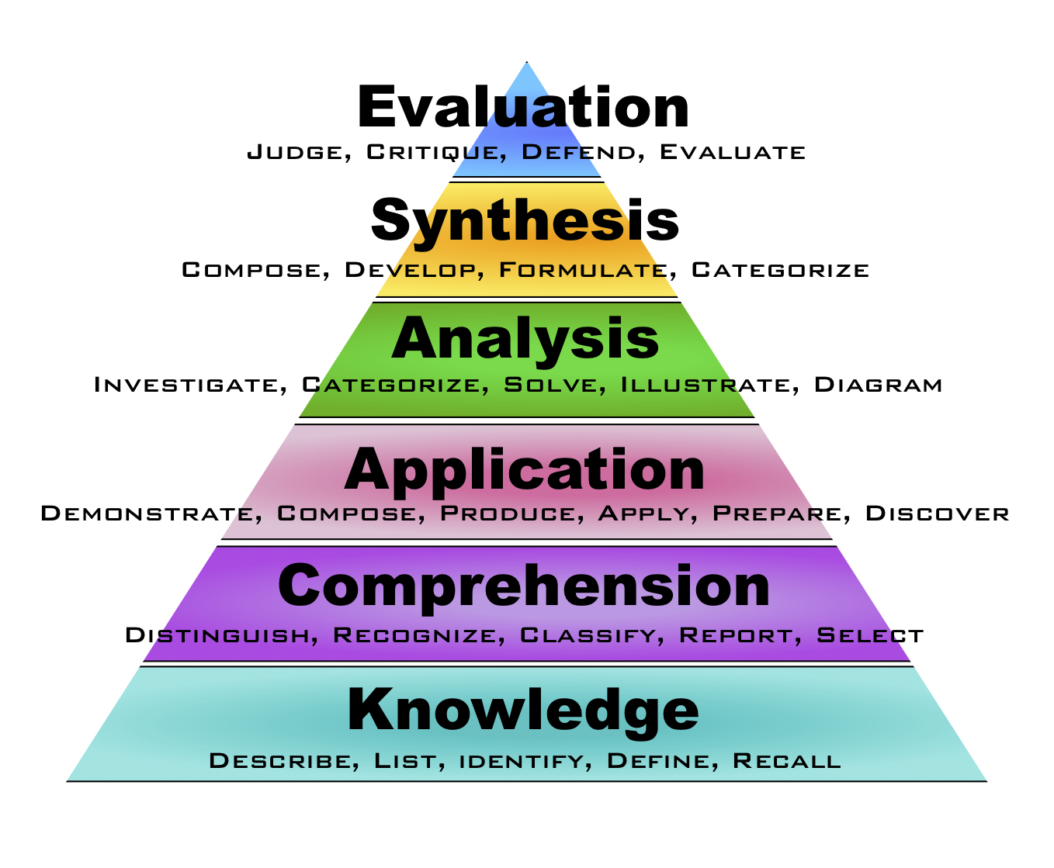 | Benjamin Bloom designed a system of classifying goals for the learning process. This system is know as “Bloom’s Taxonomy.”  There are 6 levels to this taxonomy, with the higher levels requiring more critical thinking than the lower levels.  Your courses will require different kinds of learning, not all of it exactly the same.

Group Discussion
- Consider the different courses you are taking this semester.
- Which of these 6 levels of learning have you been asked to use so far this term?
- Come up with specific examples, discuss relevant details, and be prepared to share the results of your discussion with the rest of the class.

